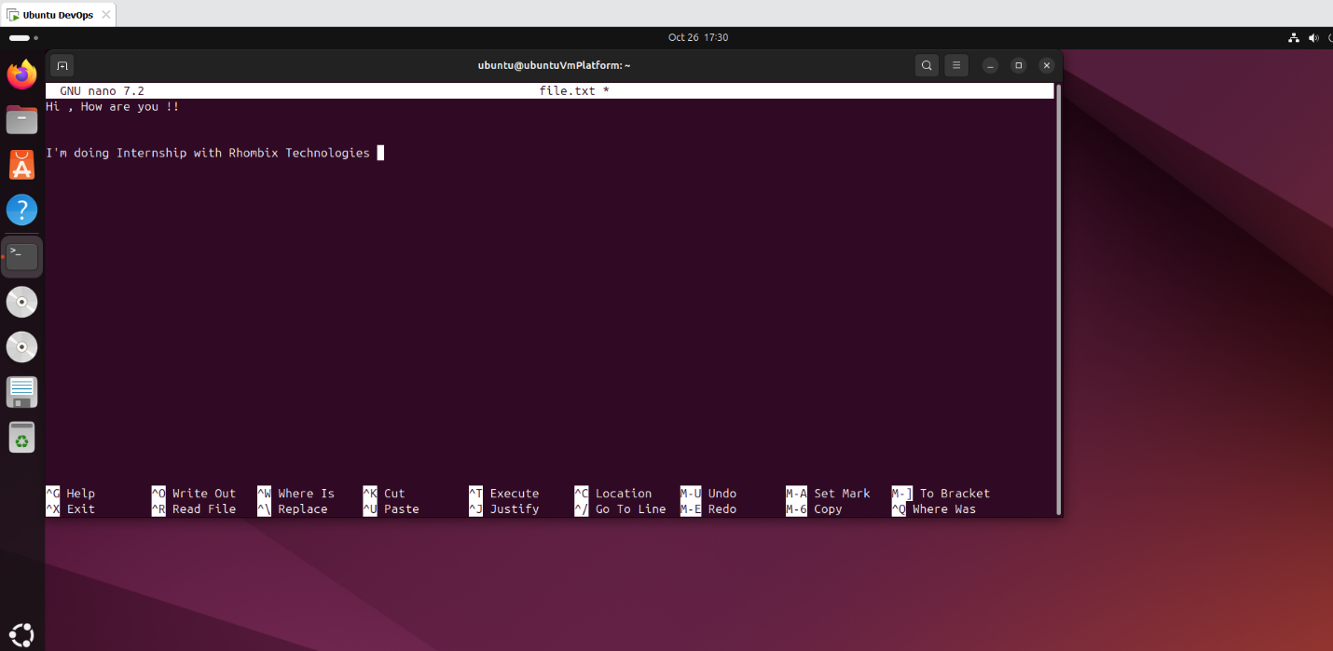

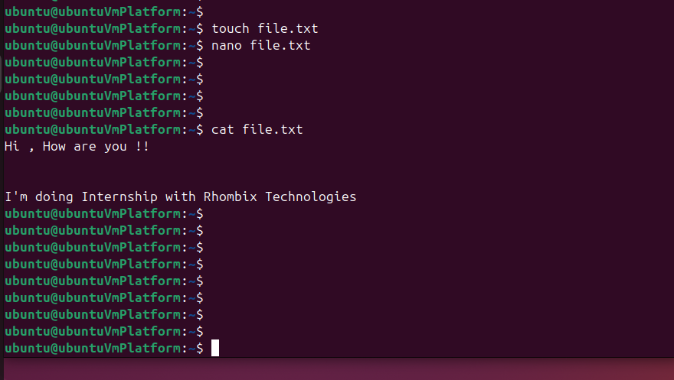

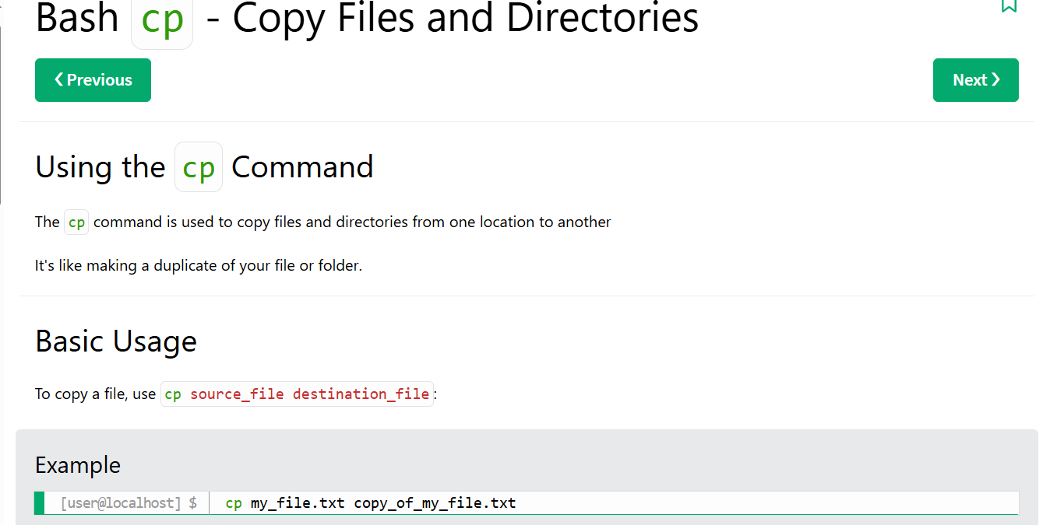

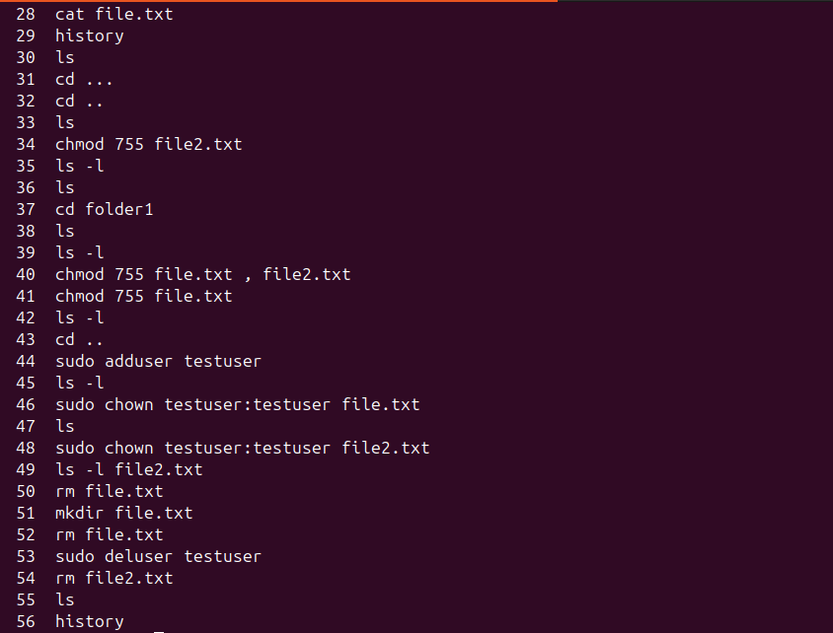
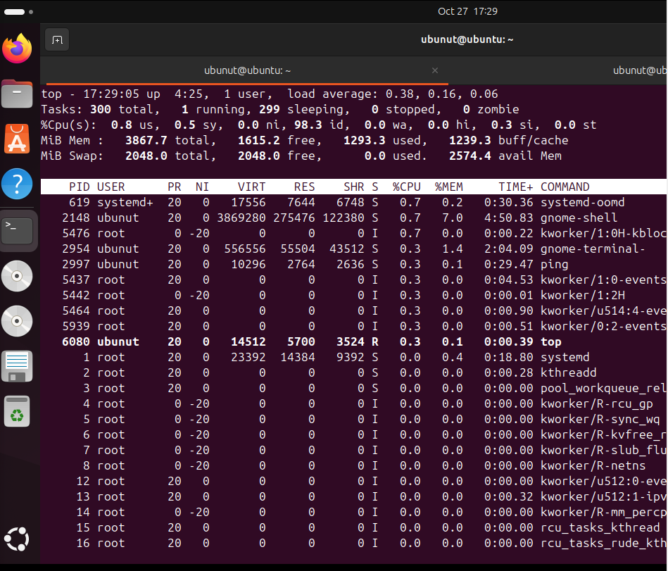
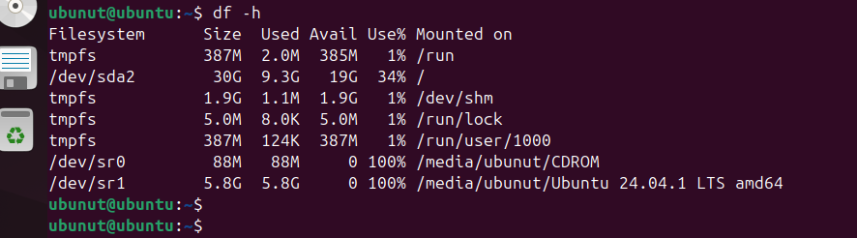

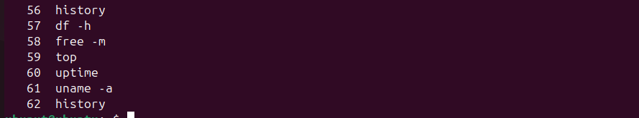
Command | Purpose | Key Output
df -h | Disk usage | Size, Used, Avail, Mounted
free -m | Memory usage | Total, Used, Free RAM
top | Running processes | CPU, Memory, Process stats
uptime | System uptime | Duration, Load average
uname -a | System info | Kernel & architecture

